Department | FED
Subject | DSA-2
Academic Year | I-III SEMESTER (2025-26)
Faculty Name | M D RAZIA
Student Name | VUNGARALA MOUKTHIKA
Roll Number | 2520030298
Branch | CSE
Course Outcome | CO-6

Case study Topic: Bangalore-to-Mumbai Logistics: Cargo Loading Optimization using the 0/1 Knapsack Problem
Work Done Summary:
Implemented and analyzed the 0/1 Knapsack Problem for cargo loading optimization. A greedy approach based on value-to-weight ratio was evaluated and compared with the Dynamic Programming (DP) solution. The optimal subset of consignments was identified while satisfying the truck's weight constraint. A Java implementation of DP with item recovery was developed, and the applicability of greedy methods to fractional knapsack scenarios was discussed.
Implementation Details:
- Represent each consignment with its weight and value.
- Apply a greedy approach by sorting items based on value-to-weight ratio.
- Calculate the total weight and value obtained using the greedy selection.
- Construct a DP table dp[i][w] where each cell stores the maximum value achievable using the first i items and capacity w.
- Fill the DP table using include/exclude decisions for each item.
- Obtain the optimal value from the final DP table entry.
- Perform backtracking on the DP table to identify the selected items.
- Compare the greedy and DP solutions and analyze their effectiveness.
Result: Screenshots / Output
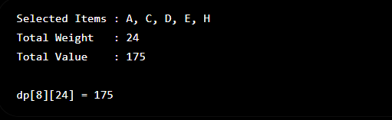

GitHub Link: moukthikavungarala/Case-Study-Project

Student Signature | Faculty Signature
__________________ | _________________

